Temperature (C) | Voltage (mV) | Temperature (K) | Resistivity (Ω cm) | log (ρ) | T^-1 x 1000
35 | 80.6 | 308 | 3.097 | 0.49 | 3.246
40 | 82.1 | 313 | 3.155 | 0.498 | 3.194
50 | 85.8 | 323 | 3.297 | 0.518 | 3.095
60 | 89.4 | 333 | 3.435 | 0.535 | 3.003
70 | 95.3 | 343 | 3.662 | 0.563 | 2.915
80 | 99.4 | 353 | 3.82 | 0.582 | 2.832
90 | 103.1 | 363 | 3.962 | 0.597 | 2.754
100 | 104.2 | 373 | 4.004 | 0.602 | 2.68
110 | 102.9 | 383 | 3.954 | 0.597 | 2.61
120 | 95.2 | 393 | 3.658 | 0.563 | 2.544
130 | 82.6 | 403 | 3.174 | 0.501 | 2.481
140 | 67.1 | 413 | 2.578 | 0.411 | 2.421
150 | 54.3 | 423 | 2.086 | 0.319 | 2.364

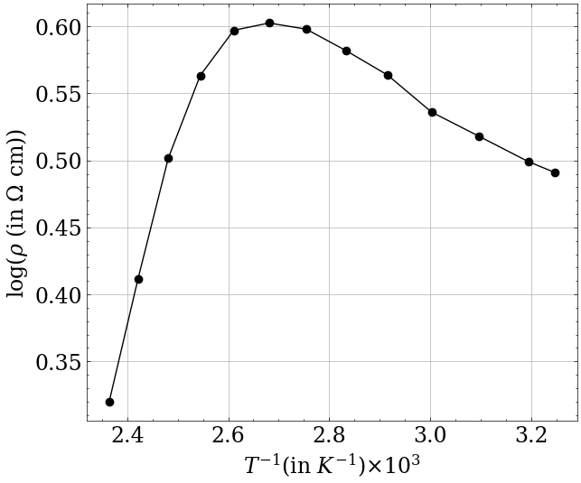

Temperature(C) | Time (s)
93.5 | 0
93.3 | 30
92.5 | 60
91.5 | 90
90.4 | 120
89.5 | 150
89.1 | 180
88.4 | 210
86.5 | 240
86.2 | 270
85 | 300
84.8 | 330
83.2 | 360
82.2 | 390
82.1 | 420
80.9 | 450
80.7 | 480
80.1 | 510
79.5 | 540
78.3 | 570
77 | 600
76.4 | 630
75.6 | 660
75.3 | 690
74.9 | 720
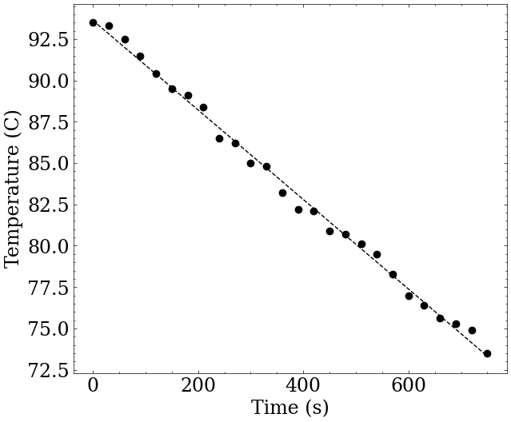  73.5 | 750

Current (mA) | V_H plus (mV) | V_H minus (mV) | Mean VH (mV) | VH/I (Ω)
0 | 0 | 0 | 0 | 0
5.03 | 4.6 | 4.5 | 4.55 | 0.905
5.53 | 5 | 4.9 | 4.95 | 0.895
5.98 | 5.4 | 5.3 | 5.35 | 0.895
6.52 | 6 | 5.9 | 5.95 | 0.913
7 | 6.4 | 6.6 | 6.5 | 0.929
7.49 | 6.9 | 6.8 | 6.85 | 0.915
8.08 | 7.5 | 7.4 | 7.45 | 0.922
8.5 | 7.9 | 7.8 | 7.85 | 0.924
9.05 | 8.4 | 8.3 | 8.35 | 0.923
9.52 | 8.9 | 8.8 | 8.85 | 0.93
10.04 | 9.4 | 9.3 | 9.35 | 0.931
10.54 | 9.9 | 9.8 | 9.85 | 0.935
10.99 | 10.1 | 10.2 | 10.15 | 0.924
11.49 | 10.6 | 10.5 | 10.55 | 0.918
12 | 11 | 11.1 | 11.05 | 0.921
12.49 | 11.5 | 11.4 | 11.45 | 0.917
12.98 | 12 | 11.9 | 11.95 | 0.921
13.75 | 12.7 | 12.6 | 12.65 | 0.92
 |  |  | mean resistance | 0.919

